Assignment-4

Dependencies:
We have used a module named ‘tkinter’ from python package and have coded using python for the user interface design (front end). Also for the front end back end (database) connectivity we have used a python module named ‘psycopg2’.

Screenshots of the code implemented for backend:
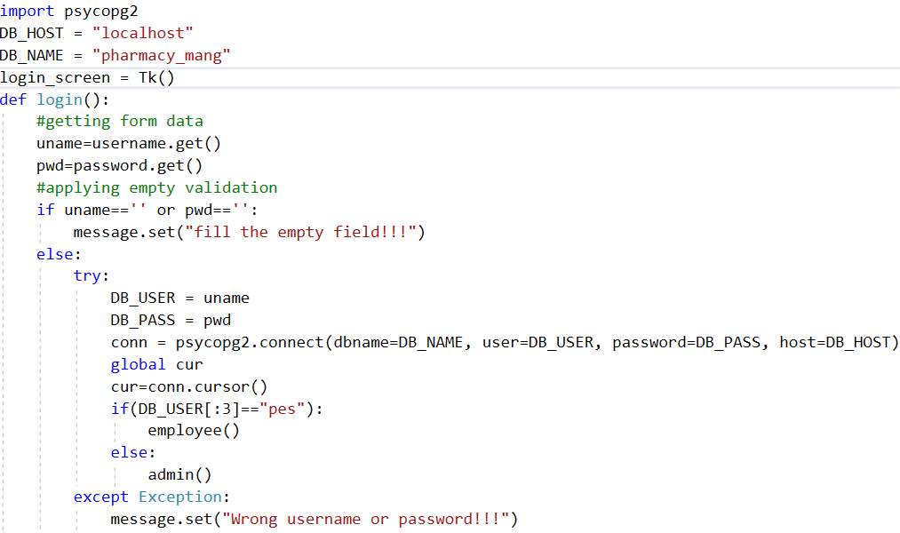
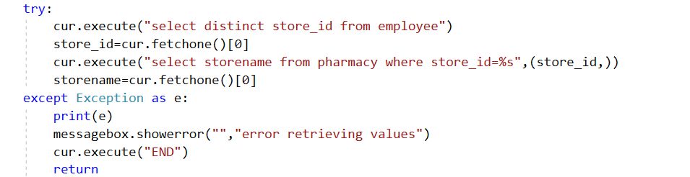
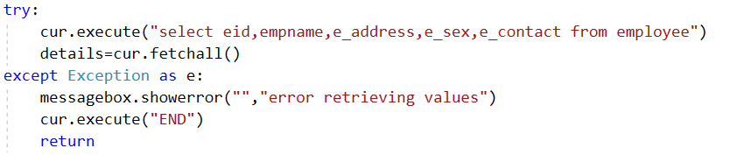
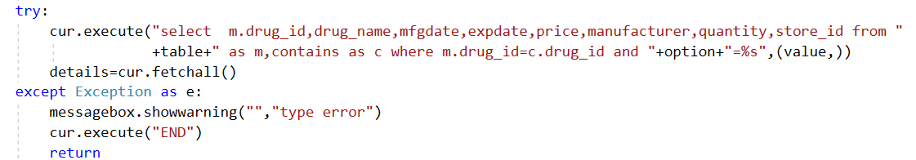
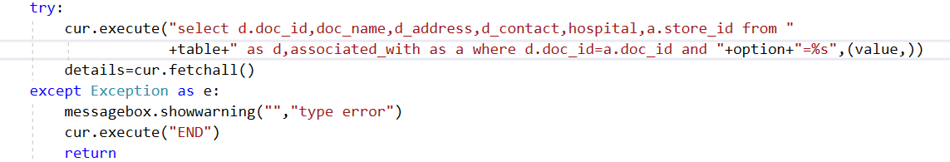
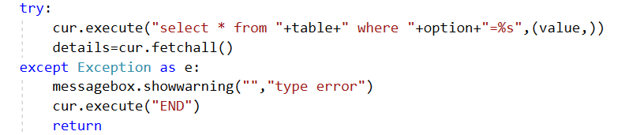
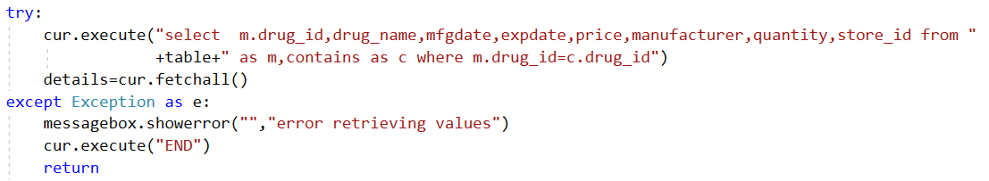
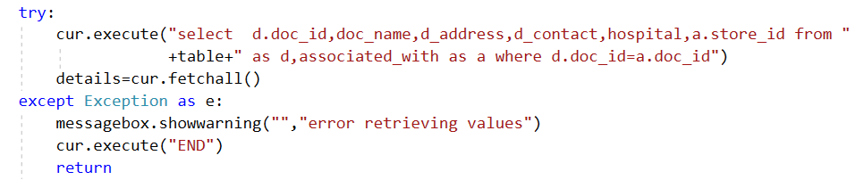
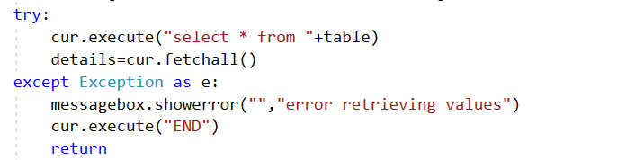
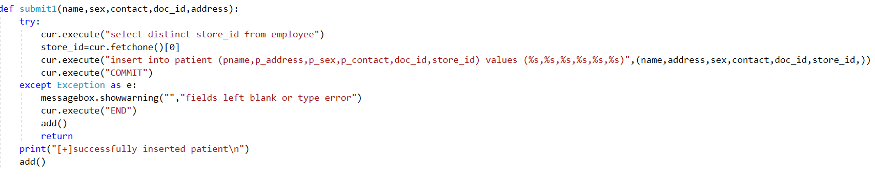
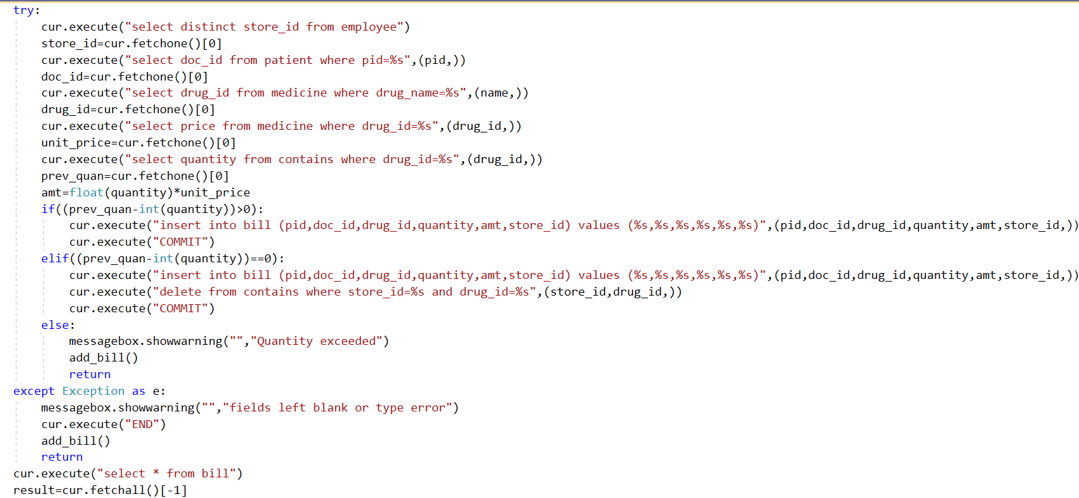
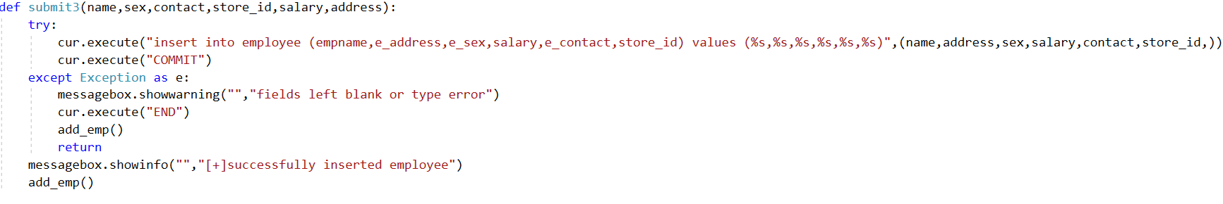
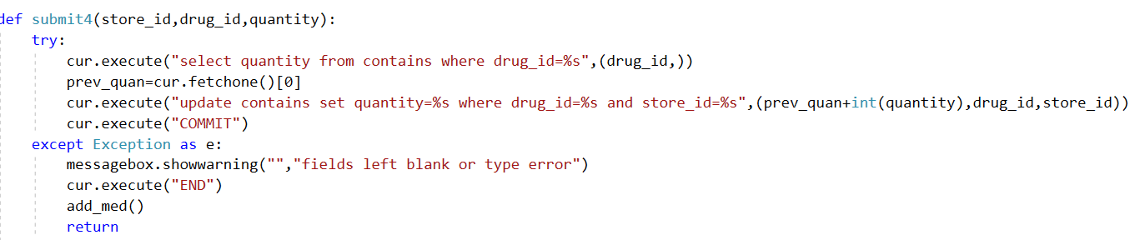

Changes:
Apart from changes that had been made in the previous assignments, not much but for tables employee, patient and bill we have changed the type of its primary key from integer to Serial type which we had not implemented at the time of creation of tables So it need not be mentioned every time a new row is inserted. Following are the screenshots.
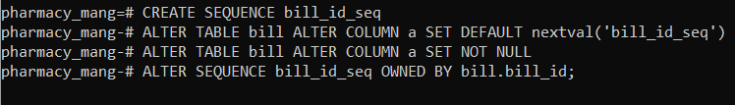

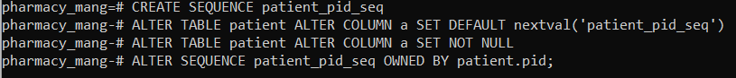

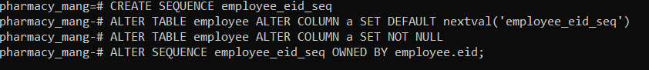

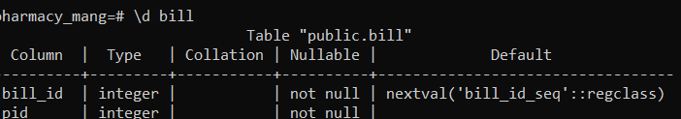

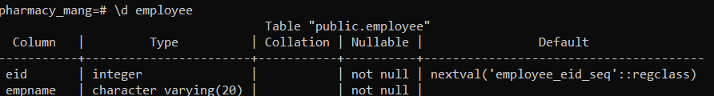

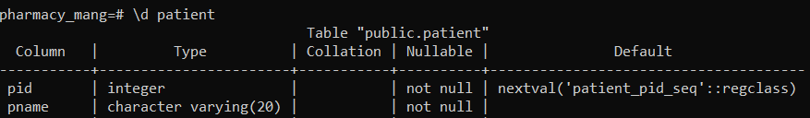

No application changes have been made while designing the interface.
DBMS migration:
To other SQL:
The process of migrating your PostgreSQL data to other SQL follows these high-level steps:
- Expose PostgreSQL Port
- Create and Connect to a New Docker Network
- Run the Portal Migration Utility
- Verify Migration Results
- Test and Run Your API Portal with the Migrated Data
To NoSQL:
PostgreSQL is a relational database management system (RDBMS). In an RDBMS, data is stored in tables, and the schema of the database must be defined on creation. While it is possible to alter tables after their creation as an application's needs change, this process can be complicated and error-prone. If chosen to migrate mongodb will be good as it is similar and in json type.

